FLOW CHART

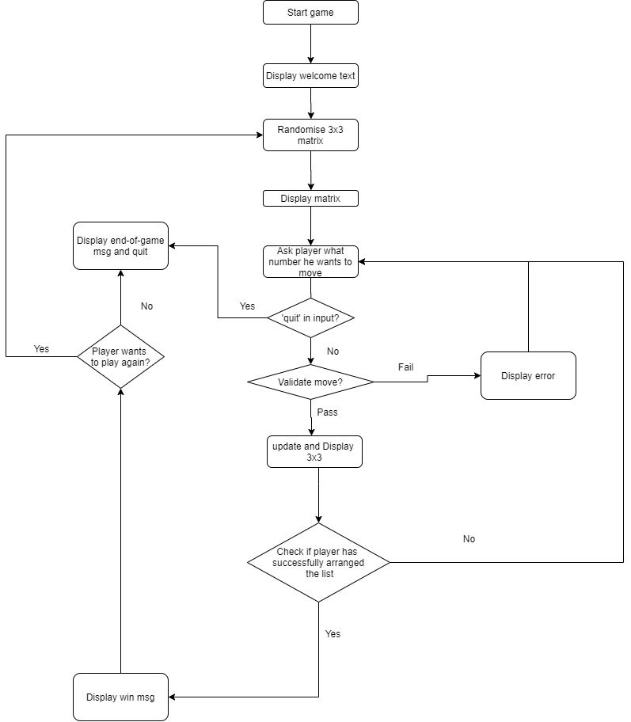

|  |  |  |  |
| --- | --- | --- | --- |
| S \ no. | Test cases | Expected result | Actual result |
|  | Enter name of game | Display welcome screen |  |
|  | Player enters “Quit” | Display quit msg and quit from game |  |
|  | Player enters invalid move (number is not adjacent to the empty cell) | Display error |  |
|  | Player enters invalid move (number is not in range (1-8) ) | Display error |  |
|  | Player enters invalid move (input is alphabet) | Display error |  |
|  | Player successfully sorts the matrix | Display congratulation msg |  |

|  |  |
| --- | --- |
| Log no. | LOGS |
| 1 | WHAT GAME DO YOU WANT TO PLAY: tiles  WELCOME TO TILES, A GAME OF LOGIC AND PATIENCE.  IN THIS GAME, YOU WILL BE GIVEN A 3x3 SCRAMBLED MATRIX.  THE EMPTY CELL IS WHERE YOU CAN MAKE YOUR MOVE.  YOU HAVE TO SORT IT IN ASCENDING ORDER (1 ON THE TOP LEFT CORNER, AND THE EMPTY SQUARE ON THE BOTTOM RIGHT CORNER).  ANYTIME YOU WANT TO QUIT, JUST ENTER "QUIT".  BEST OF LUCK  3 | 2 |  ---|---|---  6 | 1 | 8  ---|---|---  5 | 4 | 7  WHAT NUMBER DO YOU WANT TO MOVE: 2  3 | | 2  ---|---|---  6 | 1 | 8  ---|---|---  5 | 4 | 7  WHAT NUMBER DO YOU WANT TO MOVE: 3  | 3 | 2  ---|---|---  6 | 1 | 8  ---|---|---  5 | 4 | 7  WHAT NUMBER DO YOU WANT TO MOVE: 6  6 | 3 | 2  ---|---|---  | 1 | 8  ---|---|---  5 | 4 | 7  WHAT NUMBER DO YOU WANT TO MOVE: 1  6 | 3 | 2  ---|---|---  1 | | 8  ---|---|---  5 | 4 | 7  WHAT NUMBER DO YOU WANT TO MOVE: 3  6 | | 2  ---|---|---  1 | 3 | 8  ---|---|---  5 | 4 | 7  WHAT NUMBER DO YOU WANT TO MOVE: 6  | 6 | 2  ---|---|---  1 | 3 | 8  ---|---|---  5 | 4 | 7  WHAT NUMBER DO YOU WANT TO MOVE: 1  1 | 6 | 2  ---|---|---  | 3 | 8  ---|---|---  5 | 4 | 7  WHAT NUMBER DO YOU WANT TO MOVE: 3  1 | 6 | 2  ---|---|---  3 | | 8  ---|---|---  5 | 4 | 7  WHAT NUMBER DO YOU WANT TO MOVE: 6  1 | | 2  ---|---|---  3 | 6 | 8  ---|---|---  5 | 4 | 7  WHAT NUMBER DO YOU WANT TO MOVE: 2  1 | 2 |  ---|---|---  3 | 6 | 8  ---|---|---  5 | 4 | 7  WHAT NUMBER DO YOU WANT TO MOVE: 8  1 | 2 | 8  ---|---|---  3 | 6 |  ---|---|---  5 | 4 | 7  WHAT NUMBER DO YOU WANT TO MOVE: 6  1 | 2 | 8  ---|---|---  3 | | 6  ---|---|---  5 | 4 | 7  WHAT NUMBER DO YOU WANT TO MOVE: 3  1 | 2 | 8  ---|---|---  | 3 | 6  ---|---|---  5 | 4 | 7  WHAT NUMBER DO YOU WANT TO MOVE: 5  1 | 2 | 8  ---|---|---  5 | 3 | 6  ---|---|---  | 4 | 7  WHAT NUMBER DO YOU WANT TO MOVE: 4  1 | 2 | 8  ---|---|---  5 | 3 | 6  ---|---|---  4 | | 7  WHAT NUMBER DO YOU WANT TO MOVE: 7  1 | 2 | 8  ---|---|---  5 | 3 | 6  ---|---|---  4 | 7 |  WHAT NUMBER DO YOU WANT TO MOVE: 6  1 | 2 | 8  ---|---|---  5 | 3 |  ---|---|---  4 | 7 | 6  WHAT NUMBER DO YOU WANT TO MOVE: 3  1 | 2 | 8  ---|---|---  5 | | 3  ---|---|---  4 | 7 | 6  WHAT NUMBER DO YOU WANT TO MOVE: 5  1 | 2 | 8  ---|---|---  | 5 | 3  ---|---|---  4 | 7 | 6  WHAT NUMBER DO YOU WANT TO MOVE: 1  | 2 | 8  ---|---|---  1 | 5 | 3  ---|---|---  4 | 7 | 6  WHAT NUMBER DO YOU WANT TO MOVE: 2  2 | | 8  ---|---|---  1 | 5 | 3  ---|---|---  4 | 7 | 6  WHAT NUMBER DO YOU WANT TO MOVE: 8  2 | 8 |  ---|---|---  1 | 5 | 3  ---|---|---  4 | 7 | 6  WHAT NUMBER DO YOU WANT TO MOVE: 3  2 | 8 | 3  ---|---|---  1 | 5 |  ---|---|---  4 | 7 | 6  WHAT NUMBER DO YOU WANT TO MOVE: 5  2 | 8 | 3  ---|---|---  1 | | 5  ---|---|---  4 | 7 | 6  WHAT NUMBER DO YOU WANT TO MOVE: 8  2 | | 3  ---|---|---  1 | 8 | 5  ---|---|---  4 | 7 | 6  WHAT NUMBER DO YOU WANT TO MOVE: 2  | 2 | 3  ---|---|---  1 | 8 | 5  ---|---|---  4 | 7 | 6  WHAT NUMBER DO YOU WANT TO MOVE: 1  1 | 2 | 3  ---|---|---  | 8 | 5  ---|---|---  4 | 7 | 6  WHAT NUMBER DO YOU WANT TO MOVE: 4  1 | 2 | 3  ---|---|---  4 | 8 | 5  ---|---|---  | 7 | 6  WHAT NUMBER DO YOU WANT TO MOVE: 7  1 | 2 | 3  ---|---|---  4 | 8 | 5  ---|---|---  7 | | 6  WHAT NUMBER DO YOU WANT TO MOVE: 8  1 | 2 | 3  ---|---|---  4 | | 5  ---|---|---  7 | 8 | 6  WHAT NUMBER DO YOU WANT TO MOVE: 5  1 | 2 | 3  ---|---|---  4 | 5 |  ---|---|---  7 | 8 | 6  WHAT NUMBER DO YOU WANT TO MOVE: 6  1 | 2 | 3  ---|---|---  4 | 5 | 6  ---|---|---  7 | 8 |  BINGO! |